Linux for Data Engineers – Group Practical Activity Brief

**Writing an Advanced Automation Script in Linux**

**Creating a System Health Monitoring Script**

1. **Writing the Script**

• Open a text editor and write the following script:

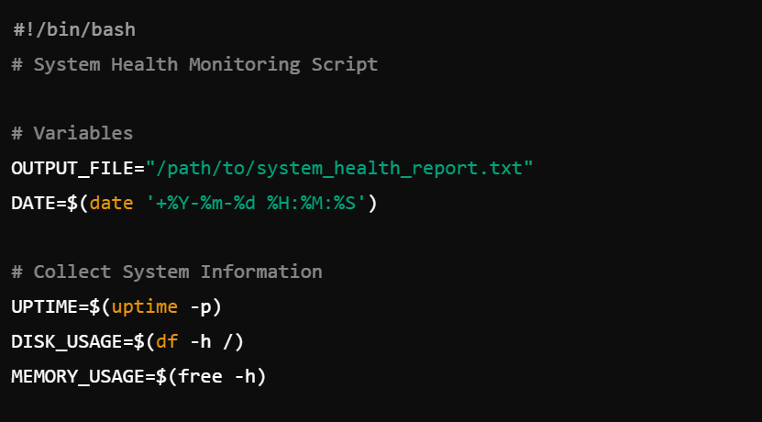

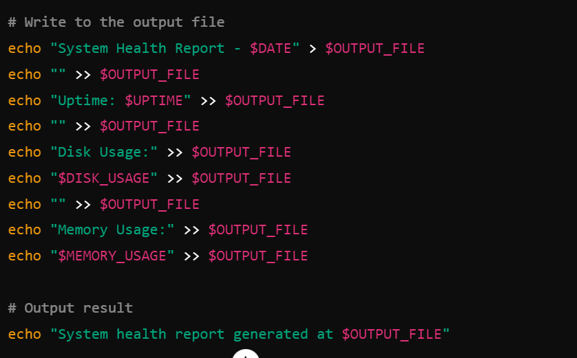

**2. Making the Script Executable**

• Change the script's permissions to make it executable:



**3. Running the Script Manually**

• Execute the script:



**4. Scheduling the Script**

• Add the script to the crontab to run daily:

